Dům umění města Brna
Malinovského nám. 2
602 00 Brno
www.dum-umeni.cz

New exhibitions at House of Arts Brno will present the work of leading artists from the Czech Republic and Vienna

Brno, 27 July 2021 – August will bring three new exhibitions and two outdoor installations to House of Arts Brno. From 3 August 2021 when at 6 pm in the presence of the Councillor for Culture of the City of Brno Council, Ing. Marek Fišer, in the foyer of the House of Arts, the exhibitions Other Things Held Constant by Jaromír Novotný, Eating Planet by Anna Hulačová and A Thirst for the Infinite by Bohuslava Olešová will be opened to visitors. As part of the last-mentioned exhibition, a spatial installation called From Nowhere to Nowhere will be created in front of the main entrance of the House of Arts. Reinhold Zisser‘s Lavka-Notgalerie will be installed in the Koliště park behind the House of Arts. The opening will be accompanied by a musical performance by Loops of Decay.

Jaromír Novotný: Other Things Held Constant

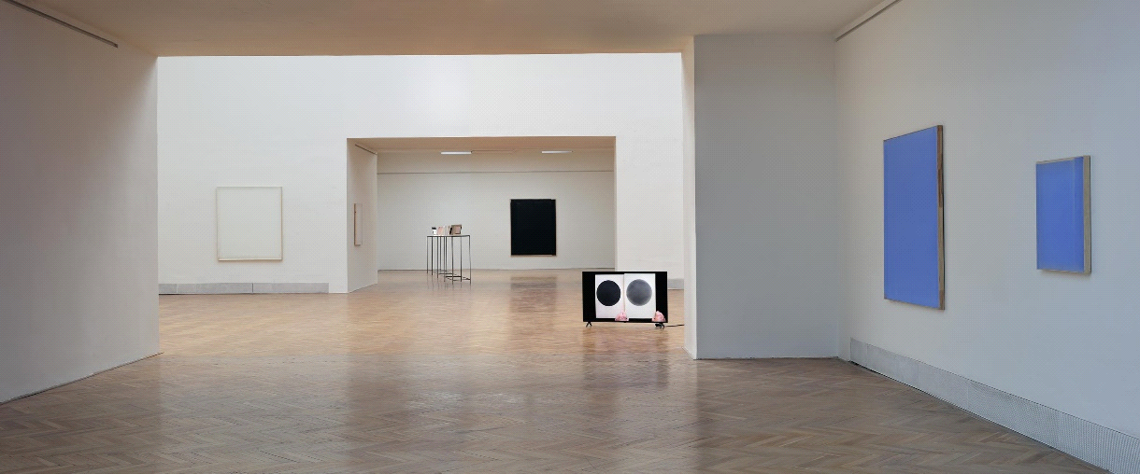
photo: Martin Polák

The exhibition on the first floor of the House of Arts will present the latest works of the artist, who is one of the most prominent figures in contemporary art in abstract monochrome painting on the domestic and international art scene. Jaromír Novotný has recently participated in the international exhibition Intuition at Palazzo Fortuny, Fondazione Musei Civici in Venice (2017), Une question de temps at Galerie Jean Brolly in Paris (2018), and last year he had solo exhibitions in Graz (Slow Gestures, Museum der Wahrnehmung) and Hong Kong (Just a Narrow Range of Possible Things, Axel Vervoordt Gallery).

The exhibition at the House of Arts, which will last from 4 August to 3 October 2021, refers in its title to the principle of ceteris paribus (Latin for "all other things being equal") used in mathematics, economics and other social sciences. It denotes a condition that examines or measures a property of one quantity under the assumption that the other quantities remain the same or constant. In the context of the exhibition, this condition can be observed in the repetition of a particular approach, slight shifts in the relationship between two elements in the image, and the inevitability of their location.

Anna Hulačová: Eating Planet

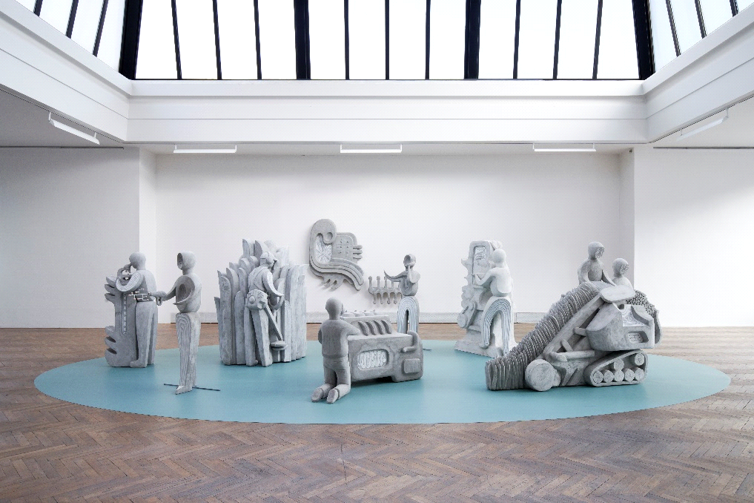
photo: Polina Davydenko

Anna Hulačová has achieved a unique position on the Czech and international contemporary art scene with her original approach to the medium of figurative sculpture. In her work she uses traditional materials - wood, wax or ceramics - but also concrete, which for her represents a symbol of civilisation or urban folklore. Her use of traditional, artisan techniques, along with references to folk art, spirituality or interwar modernist artistic styles, are translated into a distinctive artistic statement that appeals for its comprehensibility and accessibility.

The exhibition in the Procházka Hall will present the latest set of sculptures and sculptural groups reflecting the current condition of agriculture, the deepening ecological and environmental crisis and the state of alienation between man and the land. Stylised human figures, devoid of their individual features, merge with the machines they operate, coalescing into a new hybrid entity. The exhibition will run following a shortened schedule from August 4 to September 19, 2021 as the sculptures will travel to the Art Encounters biennial in Romania after the exhibition ends.

Bohuslava Olešová: A Thirst for the Infinite

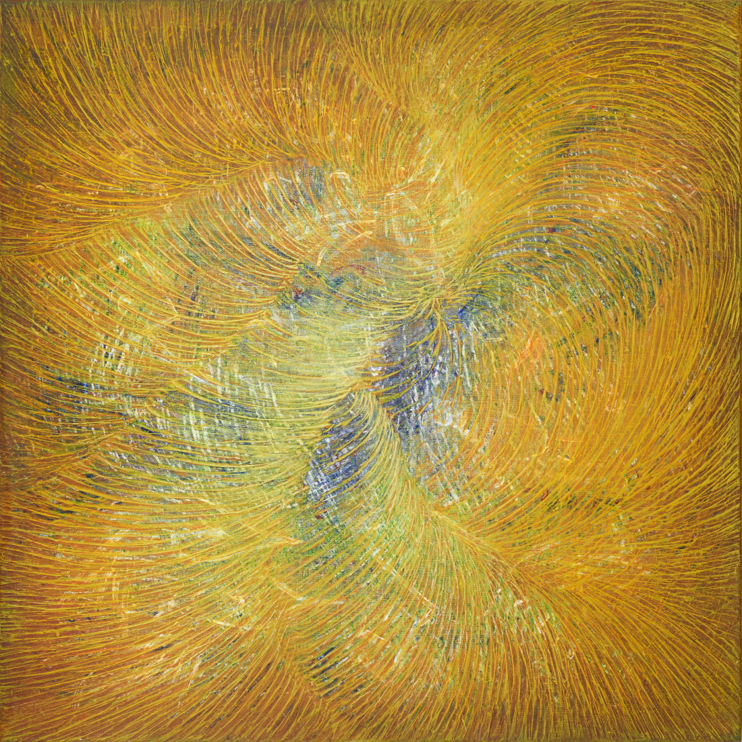

The work of Bohuslava Olešová has long been concerned with cycles of paintings, drawings, spatial installations, site-specific projects and events that mirror all-pervading energies, the relationships between life on earth and the position of man in the cosmos. It is one of these extensive cycles, A Thirst for the Infinite, that gave the title to the exhibition at the Jaroslav Král Gallery. In her works, the artist interprets the intertwining time and storylines by layering colour surfaces and drawing interventions - older and newer layers of paint merge in the same way that the human past merges with the present. By subsequently cutting through the layer of paints, all sorts of hidden histories and secrets are suggested. In addition, the colour symbolism enhances the ideological message of the work.

The exhibition will be open from 4 August to 3 October 2021 and includes the outdoor installation From Nowhere to Nowhere in front of the main entrance to the House of Arts.

Reinhold Zisser: Lavka-Notgalerie

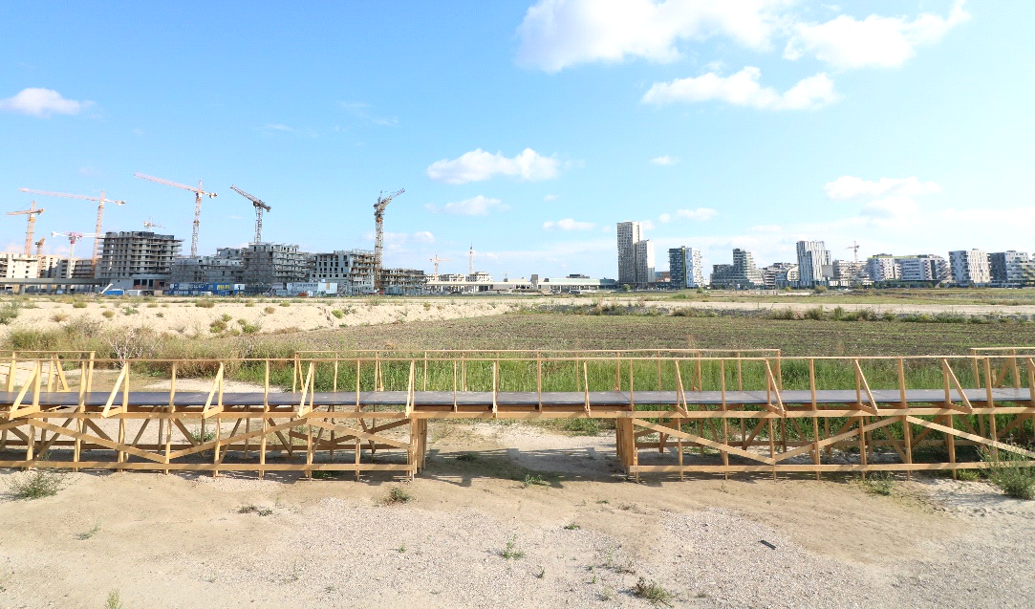

With his installation Lavka-Notgalerie in the Koliště Park behind the House of Art, Austrian artist Reinhold Zisser materialised his idea that, in relation to an institution, an artist is like a hermit crab, inhabiting an empty shell only to leave it after a certain period of time and replace it with another. His Lavka is a transformation of the wooden, thirty-metre-long bridge that originally spanned Martin Zet's exhibition Sculptor Miloš Zet: Walls, Plinths and Models at the House of Art in 2020. Reinhold Zisser was a residential artist in Brno at the same time and arranged with Czech artist Martin Zet to take this section of his exhibition to Vienna as part of the summer programme of the Notgalerie operated by him. The collaboration between Zisser and Zet has been developing since then - a continuation being the recent exhibition at the G99 Gallery, and now the relocation and new transformation of the Lavka-Notgalerie in the Koliště Park behind the House of Arts. The installation, manifesting the artistic collaboration between Brno and Vienna, will be on display in the park from 4 August 2021.

Contact for media: Anna Kvášová, kvasova@dum-umeni.cz, tel. 731 506 376

